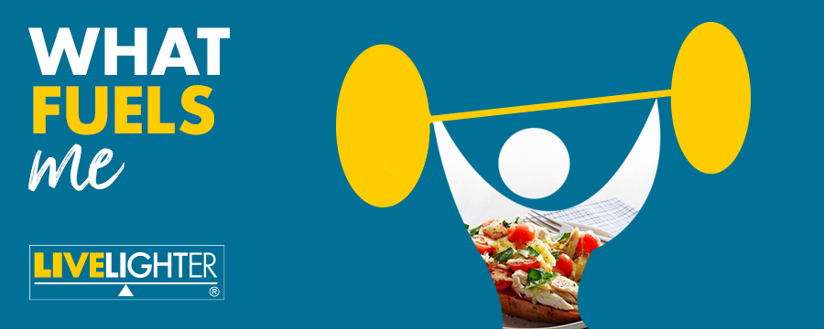
LiveLighter® What Fuels Me Campaign: Social Media Toolkit
Campaign background
Cancer Council WA has developed a new social media campaign to coincide with the 2020 Tokyo Olympics and Paralympics, which runs from July until September 2021.
What Fuels Me is designed to show that eating well isn’t just the realm of professional athletes. A healthy diet helps us all get the most out of life.
The new social tiles for Facebook, Instagram, and Twitter merge imagery of popular sports with healthy LiveLighter® meal options, to motivate people to fuel their bodies with nutritious foods when they might be inspired to try new sports and activities.
Thanks to the LiveLighter® partnership with Healthway, three Western Australian sports ambassadors are featured; Courtney Bruce from West Coast Fever, Liam Reddy from Perth Glory, and Verity Long-Droppert from Western Flames.
The campaign targets Western Australian adults and will promote the healthy recipe and physical activity resources on the LiveLighter® website, including a new selection of ‘everyday fuel’ recipes to correspond with the campaign’s message.

Social media assets

LiveLighter® is encouraging stakeholders to support the What Fuels Me campaign by sharing our social media content through your channels during the Olympic Games period.
When sharing campaign content, please tag LiveLighter® with the relevant handles (see below) and share with the hashtags #LiveLighter and #WhatFuelsMe
 | @LiveLighterCampaign |  | @Live_Lighter |  | @livelightercampaign
 | @livelightercampaign |  | @LiveLighterCampaign
Alternatively, you can share any of our posts from the LiveLighter® Facebook, Twitter, and Instagram accounts. To repost original content via Instagram, you can download an app called ‘Repost’.

Campaign social media assets

All digital tiles, blurbs and banners can be downloaded via this link:
https://livelighter.com.au/For-Professionals/What-Fuels-Me-Social-Media-Assets

Campaign key messages
- Healthy food fuels fitness for everyone, not just our sporting heroes.
- Simple, healthy meals can support your fitness goals, no matter your age or ability.
- Physical activity strengthens your muscles and bones, helps to maintain body weight and improves mental health.
- Try to be active on most days of the week – even a small amount of physical activity is better than none.
- It’s easy to make quick, tasty, and nutritious meals at home that don’t cost a lot and require minimal planning.
- A healthy diet and regular exercise can help reduce the risk of chronic diseases like heart disease, type II diabetes and cancer.
If you have any questions about our social media content or campaign materials, please contact the LiveLighter® Communication Coordinator Jasmine Teo:

Jasmine Teo | Communication Coordinator – LiveLighter®
Telephone: 08 6389 7846
Email: jasmine.teo@cancerwa.asn.au

LiveLighter® What Fuels Me social media content
Social media tiles and blurbs
Social tiles and links  Click here to download all social media assets. | Facebook copy  Copy and paste the blurb directly into a Facebook post.  *Remember to “tag” @LiveLighterCampaign in your post* | Instagram copy  Copy and paste the blurb directly into an Instagram post.  Links don’t work in Instagram posts, so add the link into your bio. Let your followers know by saying something like “To find out more, click the link in our bio”. | Instagram hashtags  Best practice is to post your hashtags as the first comment on your post.  Aim to use a minimum of 15 #hashtags to achieve maximum reach. | Twitter copy  Copy and paste the blurb directly into your Twitter post.  There’s a maximum of 280 characters (including spaces)
Campaign tile. 1  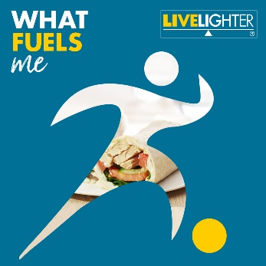  Click here to download the image | You don’t need a medal to be a champion. Be a homegrown hero by making healthy meals to fuel you and your family. ⚽️🏃‍♀️💨⁠  For healthy @LiveLighterCampaign recipe ideas, visit: https://bit.ly/3zf9BI7  #WhatFuelsMe #LiveLighter #MoveMore | You don’t need a medal to be a champion. Be a homegrown hero by making healthy meals to fuel you and your family. ⚽️🏃‍♀️💨⁠  For healthy @livelightercampaign recipe ideas, visit the link in our bio. #WhatFuelsMe #LiveLighter #MoveMore  Add this link into your bio:  https://livelighter.com.au/recipe/tag/everyday%20fuel | #LiveLightercampaign #What #Fuels #Me #Fuel #Family #Familyrecipes #Healthy #Recipes #Recipeideas #Healthyrecipes ##Healthylifestyles #Healthyhabits #Healthyeating #Physicalactivity #Physical #Activity #Physicallyactive #Stayactive #Staymotivated #Homegrown #Hero #Champion #Linkinbio | You don’t need a medal to be a champion. Be a homegrown hero by making healthy meals to fuel you and your family. ⚽️🏃‍♀️💨⁠  For healthy @Live_Lighter recipe ideas, visit: https://bit.ly/3zf9BI7 #WhatFuelsMe #LiveLighter #MoveMore
Tile | Facebook copy | Instagram copy | Instagram Hashtags | Twitter copy
Campaign tile. 2  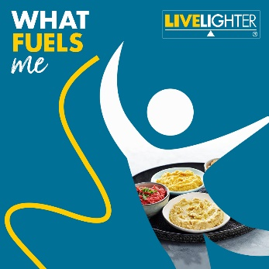  Click here to download the image | Make like an athlete and get moving! 🤸‍♂️  Doing something is better than nothing, and more is better! If you currently do no physical activity, start by doing some, and gradually build up to the recommended amount.  If you need some inspo, check out the FREE @LiveLighterCampaign home workouts and exercise guides here: https://bit.ly/2W0f7QN #WhatFuelsMe #LiveLighter | Make like an athlete and get moving! 🤸‍♂️  Doing something is better than nothing, and more is better! If you currently do no physical activity, start by doing some, and gradually build up to the recommended amount.  If you need some inspo, check out the FREE @livelightecampaign home workouts and exercise guides, by clicking on the link in our bio #WhatFuelsMe #LiveLighter  Add this link into your bio:  https://livelighter.com.au/The-Facts/About-Physical-Activity | #LiveLightercampaign #What #Fuels #Me #Fuel #Family #Familyrecipes #Healthy #Recipes #Recipeideas #Healthyrecipes #Health #Nutrition #Cooking #Athome #Healthylifestyles #Healthyhabits #Healthyeating #Physicalactivity #Physical #Activity #Physicallyactive #Stayactive #Staymotivated #Getmoving #MoveMore #Athomeworkouts #Athlete #GetMoving #Something #Isbetterthannone #Exerciseplans #Linkinbio | Make like an athlete and get moving!🤸‍♂️  Doing something is better than nothing, and more is better! If you currently do no physical activity, start by doing some and gradually build up to the recommended amount.  Find FREE at-home workouts here: https://bit.ly/2W0f7QN  @Live_Lighter
Tile | Facebook copy | Instagram copy | Instagram Hashtags | Twitter copy
Campaign tile. 3  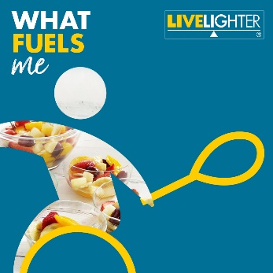  Click here to download the imaage | Be a champion in the kitchen and try one of the delicious @LiveLighterCampaign recipes. They’re packed full of flavour and nutrients to help fuel your body.  They’ve got loads of healthy options to choose from, ranging from tasty lunches to family dinners and healthy desserts. 😍🥗🍝  Check out the suite of recipes here: https://bit.ly/3zf9BI7  #WhatFuelsMe #LiveLighter #MoveMore | Be a champion in the kitchen and try one of the delicious @livelightercampaign recipes. They’re packed full of flavour and nutrients to help fuel your body.  They’ve got loads of healthy options to choose from, ranging from tasty lunches to family dinners and healthy desserts. 😍🥗🍝  Check out the suite of recipes by clicking on the link in our bio. #WhatFuelsMe #LiveLighter #MoveMore  Add this link into your bio:  https://livelighter.com.au/recipe/tag/everyday%20fuel | #LiveLightercampaign #What #Fuels #Me #Fuel #Family #Familyrecipes #Healthy#Healthyrecipes #Healthylifestyles #Healthyhabits #Healthyeating #Physicalactivity #Physical #Activity #Physicallyactive #Stayactive #Staymotivated #Flavour #Delicious #Nutrients #HealthyLunches #Healthydinners #Healthydesserts #Linkinbio | Be a champion in the kitchen and try one of the delicious @Live_Lighter recipes. They’re packed full of flavour and nutrients to help fuel your body.  There’s loads of healthy options to choose from, ranging from tasty lunches to family dinners and healthy desserts. https://bit.ly/3zf9BI7  *Please tag @Live_Lighter campaign in the image.
Tile | Facebook copy | Instagram copy | Instagram Hashtags | Twitter copy
Campaign tile. 4  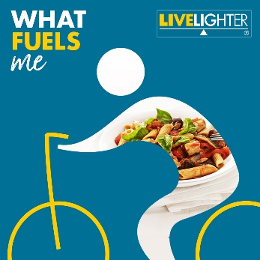  Click here to download the image | Get moving, enjoy the great outdoors and spend some quality time with family and friends!  For a fun and free activity, why not try cycling around the river, park or by the beach this weekend? 🚴💨  For more ideas on how to get moving visit: https://bit.ly/2CMsEPB @LiveLighterCampaign #WhatFuelsMe #LiveLighter #MoveMore | Get moving, enjoy the great outdoors and spend some quality time with family and friends!  For a fun and free activity, why not try cycling around the river, park or by the beach this weekend? 🚴💨  For more ideas on how to get moving, click on the link in our bio. @livelightercampaign #WhatFuelsMe #LiveLighter  Add this link into your bio:  https://livelighter.com.au/The-Facts/About-Physical-Activity/Move-More | #LiveLightercampaign #What #Fuels #Me #Fuel #Family #Familyrecipes #Healthy #Recipe #Recipeideas #Healthyrecipes #Health #Nutrition #Physicalactivity #Physical #Activity #Physicallyactive #Stayactive #Staymotivated #MoveHarder #Workyourbody #Fitter #Improvesleep #ImproveMood #Healthylifestyle #Linkinbio | Get moving, enjoy the great outdoors and spend some quality time with family and friends!  For a fun and free activity, why not try cycling around the river, park or by the beach this weekend? 🚴💨  For ideas on how to get moving, visit👉https://bit.ly/2CMsEPB @Live_Lighter
Tile | Facebook copy | Instagram copy | Instagram Hashtags | Twitter copy
Campaign tile. 5  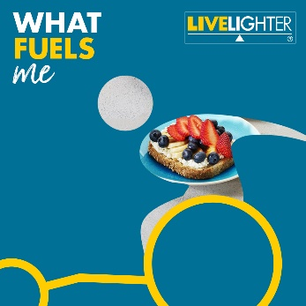  Click here to download the image | Fuel yourself right for cheering on your favourite Athlete. 🙌  Adding a healthy and nutritious topping to your toast is a quick and easy way to spruce up your meal and is perfect for an on-the-go snack!  For healthy @LiveLighterCampaign recipes that will help to fuel you right visit: https://bit.ly/3zf9BI7  #WhatFuelsMe #LiveLighter | Fuel yourself right for cheering on your favourite athlete.! 🙌  Adding a healthy and nutritious topping to your toast is a quick and easy way to spruce up your meal and is perfect for an on-the-go snack!  For healthy @LiveLighterCampaign recipes that will help to fuel you right, visit the link in our bio.  #WhatFuelsMe #LiveLighter  Add this link into your bio:  https://livelighter.com.au/recipe/tag/everyday%20fuel | #LiveLightercampaign #What #Fuels #Me #Fuel #Family #Familyrecipes #Healthy #Recipe #Recipeideas #Healthyrecipes #Health #Nutrition #Cooking #Athome #Healthylifestyles #Healthyhabits #Healthyeating #Physicalactivity #Physical #Activity #Physicallyactive #ToastToppers #Healthyoptions #Fuelyourself #Healthylifestyle #Linkinbio | Fuel yourself right for cheering on your favourite athlete!  Adding a healthy and nutritious topping to your toast is a quick and easy way to spruce up your meal and is perfect for an on-the-go snack!  For delicious recipes that will help to fuel you right visit: https://bit.ly/3zf9BI7  *Please tag @Live_Lighter campaign in the image.
Tile | Facebook copy | Instagram copy | Instagram Hashtags | Twitter copy
Campaign tile. 6  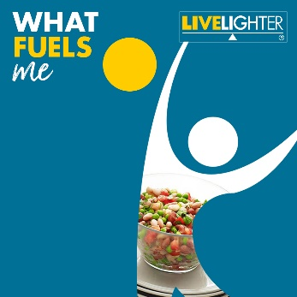  Click here to download the image | Did you know that sitting too much is linked to a number of health risks, including weight gain and an increased risk of chronic disease?  Here are our top tips to help break up your sitting time and move more often! 🚶💨  ☑️ Break up periods of sitting or standing with small bursts of physical activity  ☑️ Catch up with friends for a walk rather than a movie  ☑️ Use a sit to stand desk at your office job  ☑️ Instead of sitting after a meal, go for a walk around the block  Find out how you can #MoveOften here: https://bit.ly/3AZrRHd  #WhatFuelsMe #LiveLighter @LiveLighterCampaign | Did you know that sitting too much is linked to a number of health risks, including weight gain and an increased risk of chronic disease?  Here are our top tips to help break up your sitting time and move more often! 🚶💨  ☑️ Break up periods of sitting or standing with small bursts of physical activity  ☑️ Catch up with friends for a walk rather than a movie  ☑️ Use a sit to stand desk at your office job  ☑️ Instead of sitting after a meal, go for a walk around the block  Find out how you can #MoveOften, by clicking on the link in our bio. #WhatFuelsMe #LiveLighter @LiveLighterCampaign  Add this link into your bio:  https://livelighter.com.au/The-Facts/About-Physical-Activity/Move-Often | #LiveLightercampaign #What #Fuels #Me #Fuel #Family #Familyrecipes #Healthy #Recipe #Recipeideas #Healthyrecipes #Health #Nutrition #Healthyhabits #Healthyeating #Physicalactivity #Physical #Activity #Physicallyactive #MoveMore #MoveOften #Toptips #Sedentary #Breakitup #Time #Linkinbio | Did you know that sitting too much is linked to a number of health risks, including weight gain and an increased risk of chronic disease?? 🚶💨  Here are our top tips on how to #MoveOften. https://bit.ly/3AZrRHd  *Please tag @Live_Lighter campaign in the image.
Tile | Facebook copy | Instagram copy | Instagram Hashtags | Twitter copy
Campaign tile. 7  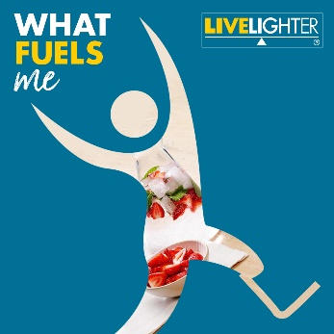  Click here to download the image | Move Harder! 😅💪  The harder you work your body, the more health benefits you will receive. Doing regular cardio reduces your risk of developing type 2 diabetes, heart disease and some cancers.  It can also help you get fitter, sleep better, and improve your mood and energy levels.  For ideas on how to #MoveHarder visit: https://bit.ly/3hYe8I4  #WhatFuelsMe #LiveLighter @LiveLighterCampaign | Move Harder! 😅💪  The harder you work your body, the more health benefits you will receive. Doing regular cardio reduces your risk of developing type 2 diabetes, heart disease and some cancers.  It can also help you get fitter, sleep better, and improve your mood and energy levels.  For ideas on how to #MoveHarder, click on the link in our bio. @livelightecampaign #WhatFuelsMe #LiveLighter  Add this link into your bio:  https://livelighter.com.au/The-Facts/About-Physical-Activity/Move-Harder | #LiveLightercampaign #What #Fuels #Me #Fuel #Family #Familyrecipes #Healthy #Recipe #Recipeideas #Healthyrecipes #Health #Nutrition #Cooking #Athome #Healthylifestyles #Healthyhabits #Healthyeating #Physicalactivity #Physical #Activity #Physicallyactive #Stayactive #Staymotivated #MoveHarder #MoveOften #Workyourbody #Fitter #Improvesleep #ImproveMood #Healthylifestyle #Linkinbio | The harder you work your body, the more health benefits you will receive. Doing regular cardio reduces your risk of developing type 2 diabetes, heart disease and some cancers. It can also help you get fitter, sleep better, and improve your mood. Read more: https://bit.ly/3hYe8I4  *Please tag @Live_Lighter campaign in the image.
Tile | Facebook copy | Instagram copy | Instagram Hashtags | Twitter copy
Campaign tile. 8  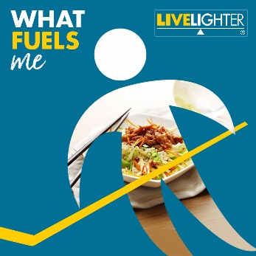  Click here to download the image | If you currently do no physical activity, start by doing some, and gradually build up to the recommended amount. Remember, the more you move, the better! 😄  Instead of catching up with friends over coffee or a movie why not try something active instead? Going for a walk around the local park (you could even have a go on some of the free fitness equipment), indoor rock climbing or bike riding are all great options!  For more ideas on how to get more movement into your week check out the top tips here: https://bit.ly/2CMsEPB  @LiveLighterCampaign #WhatFuelsMe #LiveLighter #MoveMore | If you currently do no physical activity, start by doing some, and gradually build up to the recommended amount. Remember, the more you move. the better! 😄  Instead of catching up with friends over coffee or a movie why not try something active instead? Going for a walk around the local park (you could even have a go on some of the free fitness equipment), indoor rock climbing or bike riding are all great options!  For more ideas on how to get more movement into your week, click on the link in our bio.  @livelightercampaign #WhatFuelsMe #LiveLighter #MoveMore  Add this link into your bio:  https://livelighter.com.au/The-Facts/About-Physical-Activity/Move-More | #LiveLightercampaign #What #Fuels #Me #Fuel #Family #Familyrecipes #Healthy #Recipe #Recipeideas #Healthyrecipes # #Healthylifestyles #Physicalactivity #Physical #Activity #Physicallyactive #Stayactive #Toptips #Active #Walks #Catchups #Bikeriding #Move #Buildup #Recommended #Amount #Linkinbio | If you currently do no physical activity, start by doing some, and gradually build up to the recommended amount. Remember, the more you move the better! 😄  For more ideas on how to get more movement into your week check out the top tips here: https://bit.ly/2CMsEPB  @Live_Lighter
Tile | Facebook copy | Instagram copy | Instagram Hashtags | Twitter copy
Campaign tile. 9  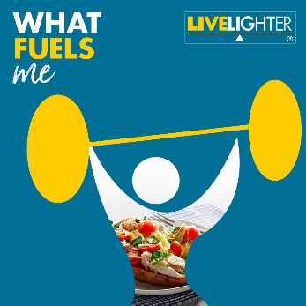  Click here to download the still image tile | To help keep your muscles and bones strong as you get older, it's important to include strengthening activities into your weekly exercise routine. 🏋️‍♀️💪😅  Doing strength activities can help to:  ✅ boost your metabolism  ✅ stabilise blood sugar levels  ✅ improve posture  ✅ reduce musculoskeletal pain and injury  ✅ improve energy levels  ✅ elevate HDL good cholesterol levels, which protects you against heart disease  Check out these beginner, intermediate and advanced level workouts, which are designed to help you get stronger in the comfort of your own home - no special gym equipment required! https://bit.ly/3yKurz2 @LiveLighterCampaign #WhatFuelsMe #LiveLighter | To help keep your muscles and bones strong as you get older, it's important to include strengthening activities into your weekly exercise routine. 🏋️‍♀️💪😅  Doing strength activities can help to:  ✅ boost your metabolism  ✅ stabilise blood sugar levels  ✅ improve posture  ✅ reduce musculoskeletal pain and injury  ✅ improve energy levels  ✅ elevate HDL good cholesterol levels, which protects you against heart disease  Check out these beginner, intermediate and advanced level workouts, which are designed to help you get stronger in the comfort of your own home - no special gym equipment required!  Click the link in our bio to find out more. @livelightecampaign #WhatFuelsMe #LiveLighter  Add this link into your bio:  https://livelighter.com.au/The-Facts/About-Physical-Activity/Move-Stronger | #LiveLightercampaign #What #Fuels #Me #Fuel #Family #Familyrecipes #Healthy #Recipe #Recipeideas #Healthyrecipes #Health #Nutrition #Cooking #Athome #Healthylifestyles #Healthyhabits #Healthyeating #Physicalactivity #Physical #Activity #Physicallyactive #Stayactive #Staymotivated #MoveHarder #Strength #Activities #Include #Inyourweek #Exercise #Routine #Workouts #Athomeworkouts #Workoutathome #linkinbio | To help keep your muscles and bones strong as you get older, it's important to include strengthening activities in your week. 🏋️‍♀️  Check out these FREE @Live_Lighter workouts, which are designed to help you get stronger in the comfort of your own home. https://bit.ly/3yKurz2
Tile | Facebook copy | Instagram copy | Instagram Hashtags | Twitter copy
Campaign tile. 10  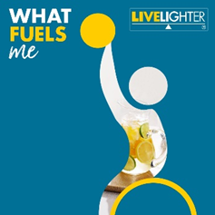  Click here to download the image | While being physically active plays a role in maintaining a healthy weight, the benefits extend well beyond this.  Moving More can help you:  ✅ Get fitter  ✅ Do everyday tasks with ease  ✅ Improve your mood  ✅ Have more energy  ✅ Sleep better  ✅ Reduce your risk of heart disease, type 2 diabetes, cancer, and other chronic diseases  There are plenty of ways you can adapt your routine to fit more physical activity into your week! For ideas on how to #MoveMore, click here: https://bit.ly/2T7Iorx  @LiveLighterCampaign  #WhatFuelsMe #LiveLighter | While being physically active plays a role in maintaining a healthy weight, the benefits extend well beyond this.  Moving More can help you:  ✅ Get fitter  ✅ Do everyday tasks with ease  ✅ Improve your mood  ✅ Have more energy  ✅ Sleep better  ✅ Reduce your risk of heart disease, type 2 diabetes, cancer, and other chronic diseases  There are plenty of ways you can adapt your routine to fit more physical activity into your week! For ideas on how to #MoveMore, click the link in our bio. @livelightecampaign #WhatFuelsMe #LiveLighter  Add this link into your bio:  https://livelighter.com.au/The-Facts/About-Physical-Activity/Move-More | #LiveLightercampaign #What #Fuels #Me #Fuel #Family #Familyrecipes #Healthy #Healthyrecipes #Healthylifestyles #Physicalactivity #Physical #Activity #MoveHarder #Strength #Activities #Include #Inyourweek #Exercise #Routine #Workouts #Athomeworkouts #Workoutathome #linkinbio #MoveOften #MoveHarder | Move More! 🤸‍♂️⛹️‍♀️🏋️There are plenty of ways you can adapt your routine to fit more physical activity into your week!  For ideas on how to #MoveMore, visit: https://bit.ly/2T7Iorx  @Live_Lighter #WhatFuelsMe #LiveLighter
Tile | Facebook copy | Instagram copy | Instagram Hashtags | Twitter copy
Campaign tile. 11  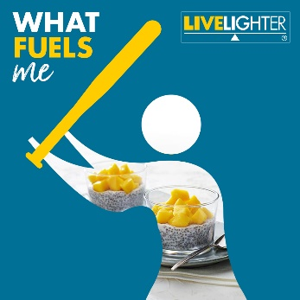  Click here to download the image | Pssst… are you looking for a quick health tip to help increase your physical activity?  Change up your environment! 😄🎯⁠  ⁠  Sticking to your goals is harder if your environment doesn’t support you. ⁠  ⁠  Think about things that can get in the way and make a concrete plan to make it easier for yourself. ⁠  ⁠  For example, instead of meeting friends at a bar, catch up for a game of team sports, a walk around the river or a ride to your local coffee shop  ⁠  For tips on how include more physical activity into your week visit: https://bit.ly/3kc6cG3  @LiveLighterCampaign #WhatFuelsMe #LiveLighter | Pssst… are you looking for a quick health tip to help increase your physical activity?  Change up your environment! 😄🎯⁠  ⁠  Sticking to your goals is harder if your environment doesn’t support you. ⁠  ⁠  Think about things that can get in the way and make a concrete plan to make it easier for yourself. ⁠  ⁠  For example, instead of meeting friends at a bar, catch up for a game of team sports, a walk around the river or a ride to your local coffee shop.  ⁠  For tips on how include more physical activity into your week, visit the link in our bio.  @livelightercampaign #WhatFuelsMe #LiveLighter  Add this link into your bio:  https://livelighter.com.au/The-Facts/About-Physical-Activity | #LiveLightercampaign #What #Fuels #Me #Fuel #Family #Familyrecipes #Healthy #Recipe #Recipeideas #Healthyrecipes #Healthylifestyles #Activities #Include #Inyourweek #Exercise #Goals #Stickingtoyourgoals #Makeaplan #Concreteplan #Changeup #Your #Environment #Switchup #YourEnvironment #MoveMore #MoveOften #MoveHarder | Sticking to your goals is harder if your environment doesn’t support you. ⁠  Think about things that can get in the way and make a concrete plan to make it easier for yourself. 🎯⁠  For tips on how to include more exercise into your week visit: https://bit.ly/3kc6cG3  @Live_Lighter
Tile | Facebook copy | Instagram copy | Instagram Hashtags | Twitter copy
Campaign tile. 12  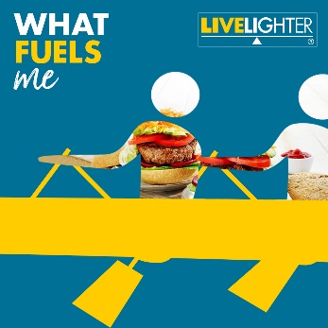  Click here to download the image | Fuel your body with nutritious and delicious food! 😋🥪🍝  @LiveLighterCampaign have a range of healthy recipes designed to excite your tastebuds and help fuel your day.  Check out their healthy recipes here: https://bit.ly/3zf9BI7  #WhatFuelsMe #LiveLighter | Fuel your body with nutritious and delicious food! 😋🥪🍝  The @livelightercampaig have a range of healthy recipes designed to excite your tastebuds and help fuel your day.  Check out their healthy recipes by clicking on the link in our bio.  #WhatFuelsMe #LiveLighter  Add this link into your bio:  https://livelighter.com.au/recipe/tag/everyday%20fuel | #LiveLightercampaign #What #Fuels #Me #Fuel #Family #Familyrecipes #Healthy #Recipe #Recipeideas #Healthyrecipes #Health #Nutrition #Cooking #Athome #Healthylifestyles #Healthyhabits #Healthyeating #Physicalactivity #Physical #Activity #Physicallyactive #Stayactive #Staymotivated #Nutritionallybalanced #Linkinbio | Fuel your body with nutritious and delicious food! 😍  LiveLighter have a range of healthy recipes designed to excite your tastebuds and help fuel your day.  https://bit.ly/3zf9BI7  @Live_Lighter
Tile | Facebook copy | Instagram copy | Instagram Hashtags | Twitter copy
Campaign tile. 13  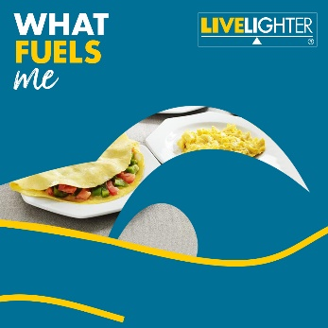  Click here to download the image | Are you moving enough each day? 🏊‍♀️🏃‍♂️  Find out with the LiveLighter physical activity calculator! You’ll get feedback on how you’re doing, plus receive personalised tips to help you meet your goals.  Check it out here: https://bit.ly/3wS29RC  @LiveLighterCampaign #WhatFuelsMe #LiveLighter | Are you moving enough each day? 🏊‍♀️🏃‍♂️  Find out with the LiveLighter physical activity calculator! You’ll get feedback on how you’re doing, plus receive personalised tips to help you meet your goals.  Check it out by visiting the link in our bio. @livelightercampaign #WhatFuelsMe #LiveLighter  Add this link into your bio:  https://livelighter.com.au/physicalactivity/calculator | #LiveLightercampaign #What #Fuels #Me #Fuel #Family #Familyrecipes #Healthy #Recipes #Recipeideas #Healthyrecipes #Healthylifestyles #Healthyhabits #Healthyeating #Physicalactivity #Physical #Activity #Physicallyactive #Stayactive #Staymotivated #MoveMore #MoveHarder #Workoutathome #Stayingactive #Healthyandhappy #calculator #physicalactivitycalculator #linkinbio | Are you moving enough each day? 🏊‍♀️🏃‍♂️  Find out with the LiveLighter physical activity calculator! You’ll get feedback on how you’re doing, plus receive personalised tips to help you meet your goals.  Check it out here: https://bit.ly/3wS29RC  @Live_Lighter #WhatFuelsMe
Tile | Facebook copy | Instagram copy | Instagram Hashtags | Twitter copy
Campaign tile. 14  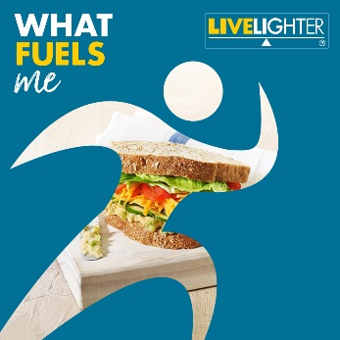  Click here to download the image | Whether you are running for the green and gold, or just running for the bus, healthy food fuels fitness for everyone. 🤩🥇  Kick-start your cardio with simple, tasty, and healthy recipes you can make at home or on the go.  For healthy @LiveLighterCampaign recipe ideas, visit: https://bit.ly/3zf9BI7  #WhatFuelsMe #LiveLighter #MoveMore | Whether you are running for the green and gold, or just running for the bus, healthy food fuels fitness for everyone. 🤩🥇  Kick-start your cardio with simple, tasty, and healthy recipes you can make at home or on the go.  For healthy @livelightercampaign recipe ideas, visit the link in our bio. #WhatFuelsMe #LiveLighter #MoveMore  Add this link into your bio:  https://livelighter.com.au/recipe/tag/everyday%20fuel | #LiveLightercampaign #What #Fuels #Me #Fuel #Family #Familyrecipes #Healthy #Recipe #Recipeideas #Healthyrecipes #Health #Nutrition #Cooking #Athome #Healthylifestyles #Healthyhabits #Healthyeating #Physicalactivity #Physical #Activity #Physicallyactive #Stayactive #Staymotivated #MoveOften #Getmoving #IncreaseYourMovements #MoveMore #MoreOften #Tasty #MoveHarder #GreenandGold #Running #Toptips #Linkinbio | Whether you are running for the green and gold, or just running for the bus, healthy food fuels fitness for everyone. 🤩🥇  Kick-start your cardio with these simple, tasty, and healthy recipes you can make at home or on the go. https://bit.ly/3zf9BI7  #WhatFuelsMe @Live_Lighter
Tile | Facebook copy | Instagram copy | Instagram Hashtags | Twitter copy
Campaign tile. 15  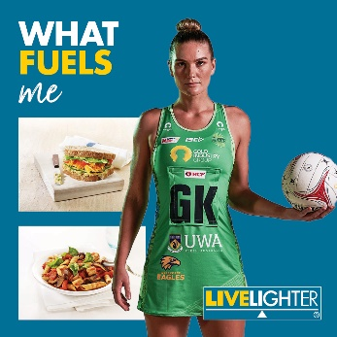  Click here to download the image | Eating well helps support everyday champions! Regardless of your age or ability, your league or level, healthier food options fuels fitness for all. 🤩🥇💪  Give these healthy recipes a shot to feel good, move more and reach your exercise goals, whatever they may be.  Check out the bank of healthy @LiveLighterCampaign recipes here: https://bit.ly/3zf9BI7  #WhatFuelsMe #LiveLighter #MoveMore @Healthway @WestCoastFever | Eating well helps support everyday champions! Regardless of your age or ability, your league or level, healthier food options fuels fitness for all. 🤩🥇💪  Give these healthy recipes a shot to feel good, move more and reach your exercise goals, whatever they may be.  Check out the bank of healthy @livelightercampaign recipes by clicking on the link in our bio.  #WhatFuelsMe #LiveLighter #MoveMore #Healthway @westcoastfeverofficial  Add this link into your bio:  https://livelighter.com.au/recipe/tag/everyday%20fuel | #LiveLightercampaign #What #Fuels #Me #Fuel #Family #Familyrecipes #Healthy #Recipe #Recipeideas #Healthyrecipes #Health #Nutrition #Cooking #Athome #WestCoastFever #NetballWA #Green #Fever #Netball #FoodforFuel #Simple #Tasty #Meals #Snacks #Athletes #LiveLighterAmbassador | Eating well helps support everyday champions! Regardless of your age or ability, your league or level, healthier food options fuels fitness for all. 🤩💪  Give these healthy recipes a shot to feel good, move more and reach your exercise goals. https://bit.ly/3zf9BI7  @Live_Lighter  *Please tag @Live_Lighter @HealthwayWA and @WestCoastFever in the image.
Tile | Facebook copy | Instagram copy | Instagram Hashtags | Twitter copy
Campaign tile. 16  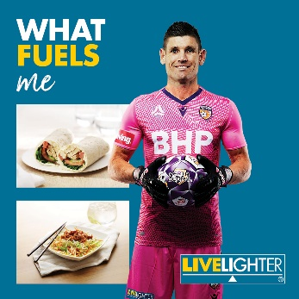  Click here to download the image | Choose healthier food options to fuel your body all the way to full time! Nutritious meals and snacks boost energy for exercise, mood and motivation. 😍🥙🍏  Throw in these simple, tasty, and healthy recipes to help you come off the bench after a long day and keep kicking towards your fitness goals all week long.  Check out the suite of healthy @LiveLighterCampaign recipes here: https://bit.ly/3zf9BI7  #WhatFuelsMe #LiveLighter #MoveMore @Healthway @PerthGlory | Choose healthier food options to fuel your body all the way to full time! Nutritious meals and snacks boost energy for exercise, mood and motivation. 😍🥙🍏  Throw in these simple, tasty, and healthy recipes to help you come off the bench after a long day and keep kicking towards your fitness goals all week long.  Check out the suite of healthy @livelightercampaign recipes, by clicking on the link in our bio.  #WhatFuelsMe #LiveLighter #MoveMore #Healthway @perthgloryfc  Add this link into your bio:  https://livelighter.com.au/recipe/tag/everyday%20fuel | #LiveLightercampaign #What #Fuels #Me #Fuel #Family #Familyrecipes #Healthy #Recipe #Recipeideas #Healthyrecipes #Health #Nutrition #Cooking #Athome #Healthylifestyles #Healthyhabits #Healthyeating #Physicalactivity #Physical #Activity #Physicallyactive #PerthGlory #PerthGloryteam #Purplearmy #Purple #Soccer #FoodforFuel #Simple #Tasty #Meals #Snacks #Athletes #Gameday #Fuel #Team #Sports #LiveLighterAmbassador | Choose healthier food options to fuel your body all the way to full time! Nutritious meals and snacks boost energy for exercise, mood and motivation.  Throw in these healthy recipes to help you come off the bench and keep kicking towards your fitness goals all week long. https://bit.ly/3zf9BI7  *Please tag @Live_Lighter @HealthwayWA and @PerthGloryFC in the image.
Tile | Facebook copy | Instagram copy | Instagram Hashtags | Twitter copy
Campaign tile. 17  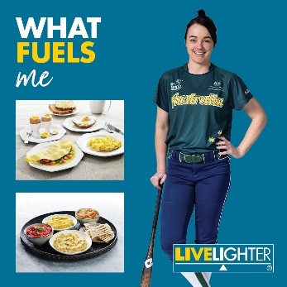  Click here to download the image | Our pitch is simple; healthy, homemade food helps everyone hit their health goals for a home run!  You don’t need to be an elite athlete to feel the difference that healthier meals can make to your mindset, motivation and energy levels. 😍💪🥗  Go into bat for the health of your household by making simple, tasty, and nutritious recipes.  Check out the healthy @LiveLighterCampaign recipes here: https://bit.ly/3zf9BI7  #WhatFuelsMe #LiveLighter #MoveMore @Healthway @SoftballWA | Our pitch is simple; healthy, homemade food helps everyone hit their health goals for a home run! You don’t need to be an elite athlete to feel the difference that healthier meals can make to your mindset, motivation and energy levels. 😍💪🥗  Go into bat for the health of your household by making simple, tasty, and nutritious recipes.  Check out the healthy @livelightercampaign recipes, by clicking on the link in our bio.  #WhatFuelsMe #LiveLighter #MoveMore #Healthway @softballwa_  Add this link into your bio:  https://livelighter.com.au/recipe/tag/everyday%20fuel | #LiveLightercampaign #What #Fuels #Me #Fuel #Family #Familyrecipes #Healthy #Recipe #Recipeideas #Healthyrecipes #Health #Nutrition #Cooking #Athome #Healthylifestyles #Healthyhabits #Healthyeating #Physicalactivity #Physical #Activity #Physicallyactive #Softball #SoftballWA #Bat #Batting #Batforyourteam #Team #Sports #LiveLighterAmbassador | Our pitch is simple; healthy, homemade food helps everyone hit their health goals for a home run! You don’t need to be an elite athlete to feel the difference that healthier meals can make to your mindset, motivation and energy levels. For recipe ideas, visit: https://bit.ly/3zf9BI7  *Please tag @Live_Lighter @HealthwayWA and @SoftballWA  in the image.

Social media banners
Promote the LiveLighter® What Fuels Me campaign by adding our campaign banners to your page
LiveLighter® What Fuels Me Facebook banner

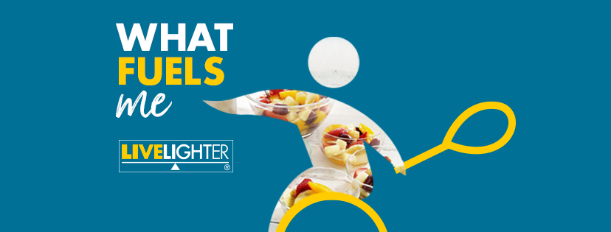
Click here to download the image

LiveLighter® What Fuels Me Twitter banner
Click here to download the image

LiveLighter® What Fuels Me website banner – option 1
Click here to download the image

LiveLighter® What Fuels Me website banner – option 2
Click here to download the image
LiveLighter® What Fuels Me newsletter banner and blurb

Click here to download the image

LiveLighter® What Fuels Me campaign

We hope you’re all looking forward to the Tokyo Olympics and Paralympics as much as we are! To coincide with this, Cancer Council WA has developed a new LiveLighter® social media campaign that will run from July until September 2021.

What Fuels Me is designed to show that eating well isn’t just the realm of professional athletes. A healthy diet helps us all get the most out of life. The new social tiles for Facebook, Instagram and Twitter merge imagery of popular sports with healthy LiveLighter® meal options, to motivate people to fuel their bodies with nutritious foods when they might be inspired to try new sports and activities. Courtesy of the LiveLighter® partnership with Healthway, the suite of creative materials also features some of our champion WA sports ambassadors.

Join LiveLighter® in promoting the campaign on social media. A social media toolkit has been developed to take all the hassle out of posting, or you can opt to simply share LiveLighter® posts.

Visit the LiveLighter® website or download the social media toolkit here for further information.

Longer URL link: https://livelighter.com.au/For-Professionals/What-Fuels-Me-Social-Media-Assets

