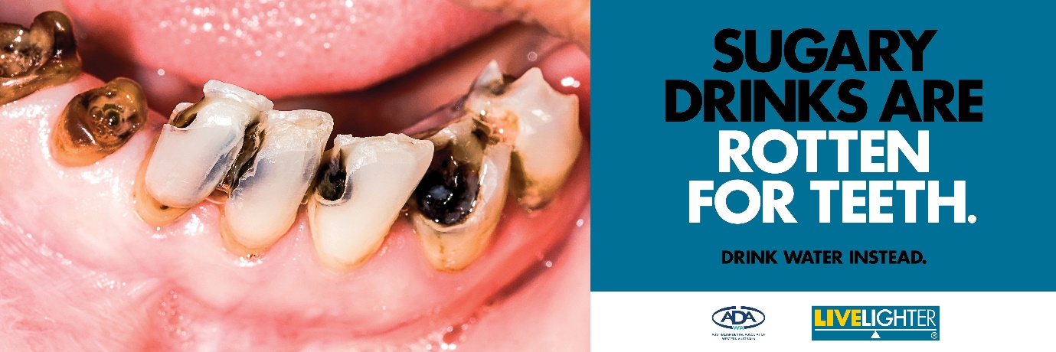
LiveLighter® Sugary Drinks Are Rotten For Teeth, Wave 2 campaign: Social Media Toolkit
Campaign background
Cancer Council WA, in partnership with the Australian Dental Association WA (ADAWA), first launched the Sugary Drinks Are a Rotten Choice campaign in January 2020.
The second wave of the campaign, Sugary Drinks are Rotten For Teeth, will run from November 8th until December 19th, 2021. This will coincide with the typical increase in sugary drink and slushie purchases and advertising over the summer period. The second wave will use a combination of outdoor and digital advertising.
The campaign aims to discourage Western Australians from purchasing sugary drinks, and to limit their consumption, by exposing the harm sugary drinks can cause to health and the damage they can do to teeth. It also aims to discourage parents from purchasing sugary drinks, and reach for water instead.
Sugary drinks are the biggest contributor of added sugar to the Australian diet and can lead to overweight and obesity, which increases the risk of chronic illness, including heart disease, type 2 diabetes and 13 different types of cancer. Sugary Drinks Are Rotten For Teeth focuses on the medium-term health consequences of tooth decay.

Social media assets

We encourage all stakeholders to support the launch of Sugary Drinks Are Rotten For Teeth campaign wave two, by sharing our social media content through their own channels.
When sharing campaign content, please tag LiveLighter® with the relevant handles (see below) and share with the hashtags #LiveLighter and #RottenForTeeth
 | @LiveLighterCampaign |  | @Live_Lighter |  | @livelightercampaign
 | @livelightercampaign |  | @LiveLighterCampaign
Alternatively, you can share any of our posts from the LiveLighter® Facebook, Twitter, and Instagram accounts. To repost original content via Instagram, you can download an app called ‘Repost’.
Campaign social media assets

All digital tiles, blurbs and banners can be downloaded via this link:
https://livelighter.com.au/Campaign-and-Media/Rotten-For-Teeth-social-media-assets
Other campaign links
Main campaign page: https://livelighter.com.au/The-Facts/About-Sugary-Drinks

Sugary Drinks Calculator: https://livelighter.com.au/sugarydrinks/calculator

Current campaign page (information for health professionals):
https://livelighter.com.au/Campaign-and-Media/Current-Campaign

Stakeholder toolkit:
https://livelighter.com.au/assets/health-professionals/toolkit/stakeholder-toolkit-livelighter-rotten-for-teeth-wave-2.pdf
Campaign key messages
- Sugary drinks like cola are our teeth’s worst enemy. They provide a big dose of sugar which the bacteria in our mouths convert to acid. This acid attacks our teeth by dissolving the outer surface of tooth enamel.
- Each acid attack brought on by sugary drinks lasts for around 20 minutes and every time you take a sip of the drink, the acid-damage cycle begins all over again.
- Sugar-free and diet soft drinks also have high acid levels which can contribute to the erosion of teeth.
- Sugary drinks can lead to unhealthy weight gain, which increases the risk of other serious chronic diseases such as cardiovascular disease, type 2 diabetes, and 13 different types of cancer.
- Drink water instead. Tap water is the best option for teeth as it’s sugar-free and the fluoride has a protective effect. It also costs practically nothing.
If you have any questions about our social media content or campaign materials, please contact the LiveLighter® social media manager Jasmine Teo:
Jasmine Teo | Communications Coordinator – LiveLighter®
Telephone: 08 6389 7846
Email: jasmine.teo@cancerwa.asn.au

LiveLighter® Sugary Drinks Are Rotten For Teeth campaign, wave 2 social media content
Social media tiles and blurbs
Social tiles and links  Click here to download all social media assets. | Facebook copy  Copy and paste the blurb directly into a Facebook post.  *Remember to “tag” @LiveLighterCampaign and @adawaoralhealth in your post* | Instagram copy  Copy and paste the blurb directly into an Instagram post.  Links don’t work in Instagram posts, so add the link into your bio. Let your followers know by saying something like “To find out more, click the link in our bio”. | Instagram hashtags  Best practice is to post your hashtags as the first comment on your post.  Aim to use a minimum of 15 #hashtags to achieve maximum reach. | Twitter copy  Copy and paste the blurb directly into your Twitter post.  There’s a maximum of 280 characters (including spaces)
Tile | Facebook copy | Instagram copy | Instagram Hashtags | Twitter copy
Campaign launch tile  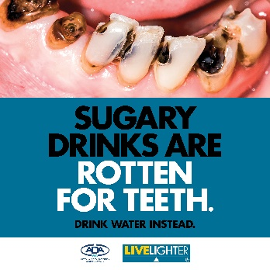  Click here to download the still image tile | LiveLighter and the Australian Dental Association WA are uniting for the second time to call for tougher restrictions on the sale and promotion of sugary drinks, and are urging people to drink water instead.  This year’s campaign aims to raise awareness of the huge impact of sugary drink consumption on dental health, and hopes to give West Australians yet another reason to ditch the sweet drinks.  To find out more about the ‘Sugary Drinks Are Rotten For Teeth’ campaign visit: https://bit.ly/3w946ud  #SugaryDrinks #RottenForTeeth #Drinkwaterinstead #ADAWA  @LiveLightercampaign  @adawaoralhealth | @livelightercampaign and @adawa_perthWA are uniting for the second time to call for tougher restrictions on the sale and promotion of sugary drinks, and are urging people to drink water instead.  This year’s campaign aims to raise awareness of the huge impact of sugary drink consumption on dental health, and hopes to give West Australians yet another reason to ditch the sweet drinks.  To find out more about the ‘Sugary Drinks Are Rotten For Teeth’ campaign, visit the link in our bio.  #SugaryDrinks #RottenForTeeth #Drinkwaterinstead #ADAWA  Add this link to your bio:  https://livelighter.com.au/The-Facts/About-Sugary-Drinks | #RottenForTeeth #Rotten #For #Teeth #SugaryDrinks #AreRottenForTeeth #Campaign #Sugary #Drinks #Drink #Water #Instead #DrinkWater #CancerCouncilWA #ADAWA #Australian #Dental #Association #WesternAustralia #SugaryDrinksCampaign #Dentalhealth #Dental #Health #Toothdecay #Impact #DitchtheSugaryDrinks #Ditch #LiveLighter #Campaign #LiveLightercampaign #Rottenteeth | .@Live_Lighter & @AUS_Dental WA call for tougher restrictions on the sale and promotion of sugary drinks, as they release their new campaign to raise awareness of the huge impact sugary drinks have on dental health and urge people to drink water instead. https://bit.ly/3w946ud  Please note*  You need to include the full stop at the start of this blurb, so that your tweet doesn’t go onto your ‘tweets and replies’ page and instead will show up on your page
Tile | Facebook copy | Instagram copy | Instagram Hashtags | Twitter copy
Campaign tile. 2  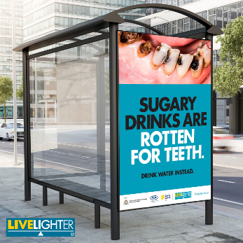  Click here to download the image | LiveLighter and the Australian Dental Association Western Australia have teamed up to develop a new campaign that focuses on the damage sugary drinks do to our teeth.  Check out ADAWA’s latest blog! It includes tips on how to cut back on sugary drinks and minimise the damage to your teeth. https://bit.ly/3khR6y3  #SugaryDrinks #RottenForTeeth #Drinkwaterinstead #ADAWA @LiveLightercampaign  @adawaoralhealth | @livelightercampaign and @adawa_perthWA have teamed up to develop a new campaign that focuses on the damage sugary drinks do to our teeth.  Check out ADAWA’s latest blog! It includes tips on how to cut back on sugary drinks and minimise the damage to your teeth.  Click on the link in our bio to read more. #SugaryDrinks #RottenForTeeth #Drinkwaterinstead #ADAWA  Add this link to your bio:  https://livelighter.com.au/news/Sugary-drinks-are-rotten-for-teeth | #RottenForTeeth #Rotten #For #Teeth #SugaryDrinks #AreRottenForTeeth #Campaign #Sugary #Drinks #Drink #Water #Instead #DrinkWater #CancerCouncilWA #ADAWA #Australian #Dental #Association #WesternAustralia #SugaryDrinksCampaign #Dentalhealth #Dental #Health #Toothdecay #Impact #DitchtheSugaryDrinks #Ditch #LiveLighter #Campaign #LiveLightercampaign #Blog #NewBlogPost #Linkinbio #Rottenteeth | .@Live_Lighter and @AUS_Dental have teamed up to develop a new campaign that focuses on the damage sugary drinks do to your teeth.  Check out ADAWA’s latest blog! It includes tips on how to cut back on sugary drinks and minimise the damage to your teeth. https://bit.ly/3khR6y3  Please note*  You need to include the full stop at the start of this blurb, so that your tweet doesn’t go onto your ‘tweets and replies’ page and instead will show up on your page
Tile | Facebook copy | Instagram copy | Instagram Hashtags | Twitter copy
Campaign tile. 3  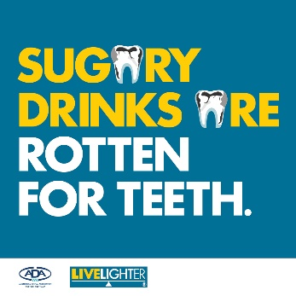  Click here to download the image | Sugary drinks are rotten for your teeth. Dr David Hallett, the Australian Dental Association WA’s CEO explains how they damage our teeth.  ⚠️ Bacteria that are naturally present in your mouth break down the sugar in sugary drinks into acids.  ⚠️ The acid attacks the teeth, dissolving the outer surface of tooth enamel.  ⚠️ Each acid attack brought on by sugary drinks lasts for about 20 minutes.  ⚠️ Every time you take a sip, the acid damage begins all over again.  ⚠️ The regular loss of enamel can lead to cavities which expose the inner layers of the tooth.  ⚠️This can ruin your smile and make teeth sensitive and painful.  ⁠  LiveLighter and the ADAWA have joined forces to raise awareness of the damage that added sugar does to our teeth and bodies.  Find out more about the links between tooth decay and sugary drink consumption here: https://bit.ly/3w946ud  #SugaryDrinks #RottenForTeeth #Drinkwaterinstead #ADAWA @LiveLightercampaign  @adawaoralhealth | Sugary drinks are rotten for your teeth. Dr David Hallett, the Australian Dental Association WA’s CEO explains how they damage our teeth.  ⚠️ Bacteria that are naturally present in your mouth break down the sugar in sugary drinks into acids.  ⚠️ The acid attacks the teeth, dissolving the outer surface of tooth enamel.  ⚠️ Each acid attack brought on by sugary drinks lasts for about 20 minutes.  ⚠️ Every time you take a sip, the acid damage begins all over again.  ⚠️ The regular loss of enamel can lead to cavities which expose the inner layers of the tooth.  ⚠️This can ruin your smile and make teeth sensitive and painful.  ⁠  LiveLighter and the ADAWA have joined forces to raise awareness of the damage that added sugar does to our teeth and bodies.  Find out more about the links between tooth decay and sugary drink by clicking on the link in our bio.  @livelightercampaign @adawa_perthWA #SugaryDrinks #RottenForTeeth #Drinkwaterinstead #ADAWA  Add this link to your bio:  https://livelighter.com.au/The-Facts/About-Sugary-Drinks | #RottenForTeeth #Rotten #For #Teeth #SugaryDrinks #AreRottenForTeeth #Campaign #Sugary #Drinks #Drink #Water #Instead #DrinkWater #CancerCouncilWA #ADAWA #Australian #Dental #Association #WesternAustralia #SugaryDrinksCampaign #Dentalhealth #Dental #Health #Toothdecay #Impact #DitchtheSugaryDrinks #Ditch #LiveLighter #Campaign #LiveLightercampaign #Rottenteeth | .@LiveLighter and the @AUS_Dental WA have joined forces to raise awareness of the damage sugary drinks do to our teeth and bodies. 🦷🥤  Find out the links between tooth decay and sugary drink consumption here: https://bit.ly/3w946ud  #SugaryDrinks #RottenForTeeth #ADAWA  Please note*  You need to include the full stop at the start of this blurb, so that your tweet doesn’t go onto your ‘tweets and replies’ page and instead will show up on your page
Tile | Facebook copy | Instagram copy | Instagram Hashtags | Twitter copy
Campaign tile. 4  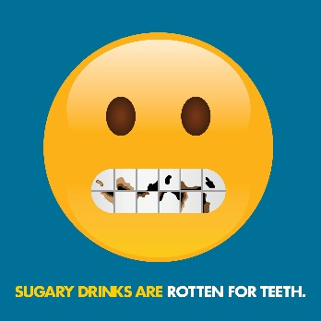  Click here to download the image | Did you know? 🤔🦷🥤  Australians aged 15 years and older have an average of 11 decayed, missing, or filled teeth, and almost a quarter of Australian adults consume sugar-sweetened beverages 1-3 times a week. Dental decay is a big issue!  LiveLighter and the Australian Dental Association WA have joined forces to combat the alarming impact sugary drinks have on dental health and encourage the community to ditch the sweet drinks.  Sugary drinks don’t just rot your teeth, they also contribute to weight gain. Being above a healthy weight increases the risk of heart disease, type 2 diabetes, fatty liver disease and 13 different types of cancer.  To find out more about the link between tooth decay and sugary drink consumption visit: https://bit.ly/3w946ud  #SugaryDrinks #RottenForTeeth #Drinkwaterinstead #ADAWA @LiveLightercampaign  @adawaoralhealth | Did you know? 🤔🦷🥤  Australians aged 15 years and older have an average of 11 decayed, missing, and filled teeth, and almost a quarter of Australian adults consume sugar-sweetened beverages 1-3 times a week. Dental decay is a big issue!  @livelightercampaign and @adawa_perthWA have joined forces to combat the alarming impact sugary drinks have on dental health and encourage the community to ditch the sweet drinks.  Sugary drinks don’t just rot your teeth, they also contribute to weight gain. Being above a healthy weight increases the risk of heart disease, type 2 diabetes, fatty liver disease and 13 different types of cancer.  To find out more about the link between tooth decay and sugary drink consumption, visit the link in our bio.  #SugaryDrinks #RottenForTeeth #Drinkwaterinstead #ADAWA  Add this link to your bio:  https://livelighter.com.au/The-Facts/About-Sugary-Drinks | #RottenForTeeth #Rotten #For #Teeth #SugaryDrinks #AreRottenForTeeth #Campaign #SugaryDrinks #Are #Sugary #Drinks #Drink #Water #Instead #DrinkWater #CancerCouncilWA #ADAWA #Australian #Dental #Association #WesternAustralia #SugaryDrinksCampaign #Dentalhealth #Dental #Health #Toothdecay #Impact #DitchtheSugaryDrinks #Ditch #LiveLighter #LiveLightercampaign #Summer #Campaign #Rottenteeth | Aussies over 15 years have an average of 11 decayed, missing, and filled teeth, and almost a quarter of Australian adults consume sugar-sweetened beverages 1-3 times a week. Dental decay is a big issue!  Find out the impact sugary drinks have on teeth here: https://bit.ly/3w946ud  Please tag* @LiveLighter and @AUS_Dental in the ‘Image’ when you upload your Tweet.
Tile | Facebook copy | Instagram copy | Instagram Hashtags | Twitter copy
Campaign tile. 5  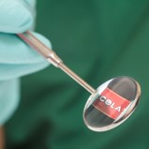  Click here to download the image | Sugary drinks don’t just rot your teeth, they also contribute to weight gain. Being above a healthy weight increases the risk of heart disease, type 2 diabetes, fatty liver disease and 13 different types of cancer.  Here are some tips on how you can reduce tooth damage from sugary drinks:  ☑ Drink water instead! It's sugar-free, and the fluoride has a positive effect  ☑ Drink them with a meal and avoid sipping sugary drinks over a long period of time  ☑ Chew sugar-free gum after drinking them  ☑ Brush teeth 30 mins after drinking a sugary drink  ☑ Build good habits early.  To find out more about the link between tooth decay and sugary drink consumption visit: https://bit.ly/3khR6y3  #SugaryDrinks #RottenForTeeth #Drinkwaterinstead #ADAWA @LiveLightercampaign  @adawaoralhealth | Sugary drinks don’t just rot your teeth, they also contribute to weight gain. Being above a healthy weight increases the risk of heart disease, type 2 diabetes, fatty liver disease and 13 different types of cancer.  Here are some tips on how you can reduce tooth damage from sugary drinks;  ☑ Drink water instead! It's sugar-free, and the fluoride has a positive effect  ☑ Drink them with a meal and avoid sipping sugary drinks over a long period of time  ☑ Chew sugar-free gum after drinking them  ☑ Brush teeth 30 mins after drinking a sugary drink  ☑ Build good habits early.  To find out more about the link between tooth decay and sugary-drink consumption, visit the link in our bio.  #SugaryDrinks #RottenForTeeth #Drinkwaterinstead #ADAWA @livelightercampaign  @adawa_perthWA  Add this link to your bio:  https://livelighter.com.au/news/Sugary-drinks-are-rotten-for-teeth | #RottenForTeeth #Rotten #For #Teeth #SugaryDrinks #AreRottenForTeeth #Campaign #SugaryDrinks #Are #Sugary #Drinks #Drink #Water #Instead #DrinkWater #CancerCouncilWA #ADAWA #Australian #Dental #Association #WesternAustralia #SugaryDrinksCampaign #Dentalhealth #Dental #Health #Toothdecay #Impact #DitchtheSugaryDrinks #Ditch #LiveLighter #LiveLightercampaign #Summer #Campaign #Rottenteeth | .@Live_Lighter and @AUS_Dental WA join forces to raise awareness of the damage that added sugar does to our teeth and bodies. 🦷🥤  For tips on how you can reduce tooth damage from sugary drinks, visit: https://bit.ly/3khR6y3  #SugaryDrinks #RottenForTeeth #ADAWA  Please note*  You need to include the full stop at the start of this blurb, so that your tweet doesn’t go onto your ‘tweets and replies’ page and instead will show up on your page
Social media banners
Promote our Sugary Drinks Are Rotten For Teeth campaign by adding our campaign banners to your page
Sugary Drinks Are Rotten For Teeth Facebook banner (as seen on the LiveLighter® Facebook page)
https://www.facebook.com/LiveLighterCampaign

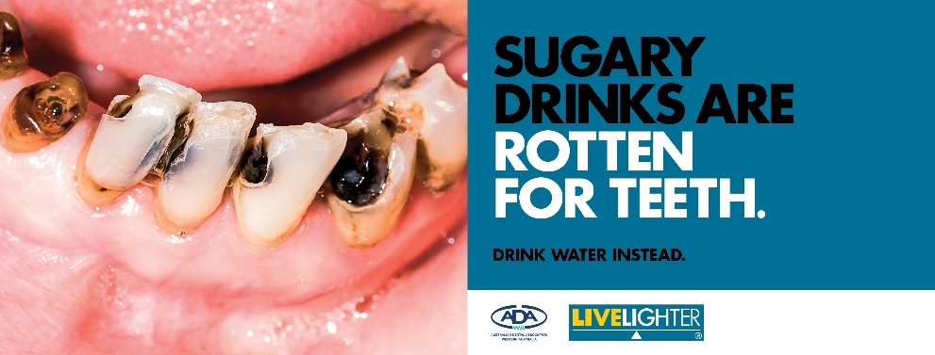
Click here to download the image

Sugary Drinks Are Rotten For Teeth Twitter banner (as seen on the LiveLighter® Twitter page)
https://twitter.com/Live_Lighter

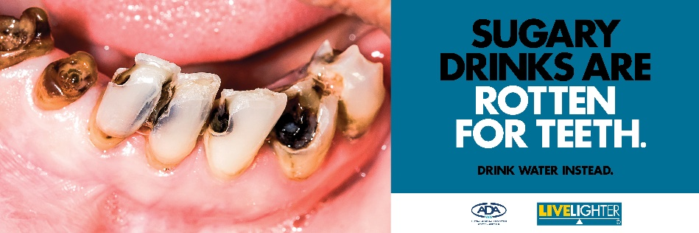
Click here to download the image

