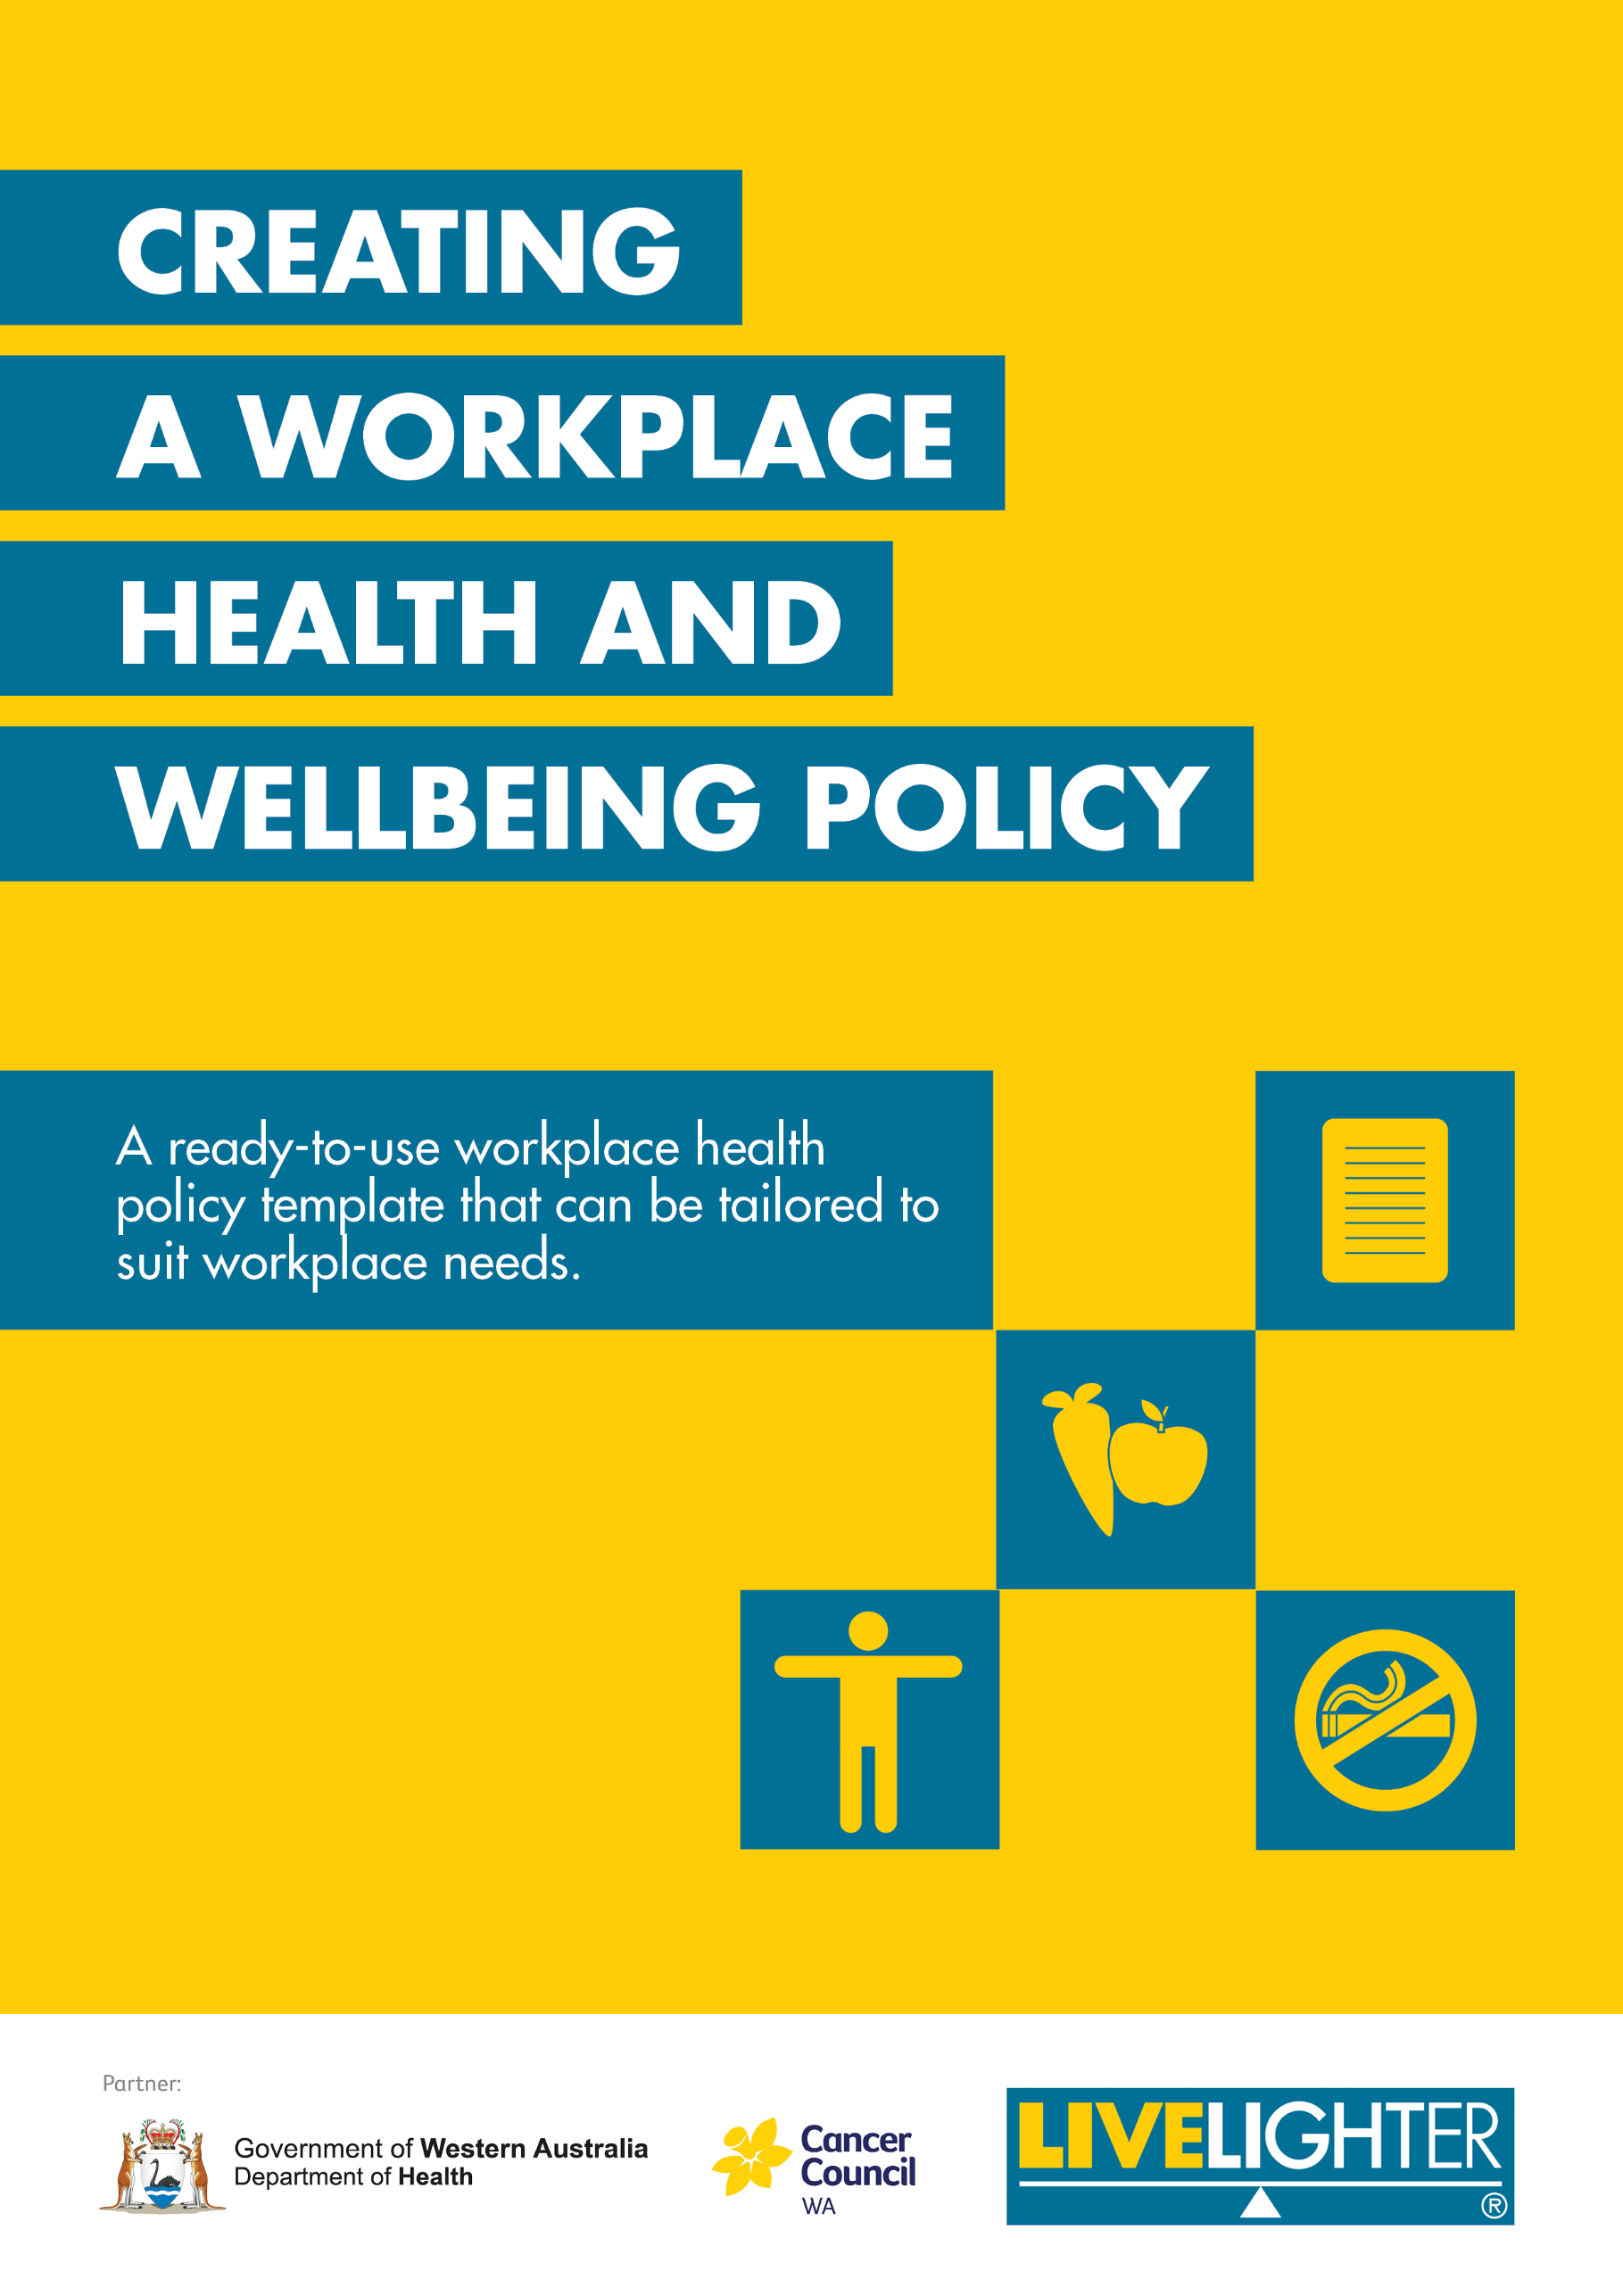

Headings
General text

Creating a workplace health and wellbeing policy
A ready-to-use workplace health policy template that can be tailored to suit workplace needs.
Creating a workplace health and wellbeing policy is an important part of a successful workplace health program. It demonstrates your organisation’s commitment to health and wellbeing and outlines the specific ways your workplace will support and encourage employee health.
Before developing your policy, it is recommended that you undertake the free Online workplace health coordinator training, which covers the basics of workplace health promotion and includes four self-paced modules to support you in developing a comprehensive and tailored workplace health program. This policy is best used in conjunction with the Toolkit for a healthier workplace resource and the Best practice guide: Workplace health and wellbeing strategies.
A good policy should include:
- A policy statement of the workplace’s commitment to the health issue.
- Clear objectives that demonstrate how your policy statement will be achieved.
- Strategies or actions that will be undertaken to achieve your objectives e.g., changes to the physical environment, education and activities. Use the Best Practice Guide: Workplace health and wellbeing strategies to find the best strategies for your workplace.
- Specific responsibilities of those within the organisation and how they will contribute to the implementation of the policy.
- A timeline to ensure the policy is monitored, updated and reviewed regularly.
- How the policy will be promoted and communicated to all employees e.g., include policy as part of the employee induction process and ensure it is easily accessible.

How to use this policy template
Use this template to tailor a health and wellbeing policy to your workplace’s needs, environment and culture. Add your workplace details, select the health priorities most relevant to your workplace, and add in the strategies you plan to implement.
This policy template focuses on the following risk factors and is based on Australian guidelines and recommendations:
- Physical inactivity;
- Unhealthy eating and drinking;
- Smoking; and
- Alcohol use.
Other workplace health priority areas (e.g., mental health, fatigue) can also be added.
It is recommended that employees are consulted during development to increase their ownership and understanding of the policy (and subsequent adherence to it). The term ‘employee’ has been used throughout the document to refer to all workers, supervisors, managers, external contractors and volunteers.
You may need to adapt your policy to suit different worksites within your workplace or include a “phased in approach” to gradually introduce any new changes to allow the workplace culture to adapt.
Some sections give prompts to [remove if not applicable]. For example, if your workplace does not have a vending machine, the section about creating healthier vending machines will not be necessary. Remember to delete all the red text before you finalise your policy.

Health and wellbeing policy
Background
The average Australian spends about one third of their life at work. This makes the workplace an important setting to address and improve health and wellbeing. A healthy worker is likely to be more productive, engaged with their work, take less sick leave and have greater levels of energy and concentration. Research also shows that healthy workers are safer workers. The aim of this health and wellbeing policy is to create a supportive work environment that encourages employees to engage in healthy lifestyle behaviours whilst at work to improve their overall health, wellbeing and productivity.

Policy statement
<insert workplace name>:
- Recognises the importance of the workplace in supporting employees to adopt healthier lifestyle behaviours.
- Values the health and wellbeing of our employees.
- Recognises that a combination of policy, environment and education and awareness raising strategies are most effective in bringing about behaviour change.
- Is committed to creating a workplace environment that supports and encourages healthier lifestyle behaviours.

Health risk factors
<insert workplace name> is committed to encouraging and supporting employees to lead healthier lifestyles through addressing the following modifiable health risk factors: <select those that are relevant>:

Physical inactivity
Being physically active and sitting less reduces the risk of chronic disease and illness, including heart diseases, type two diabetes and some cancers. These actions can help increase energy levels, provide stress relief and encourage social interaction.

On average, desk or office-based employees spend more than three quarters of their work day sitting. Sitting for long periods of time reduces blood flow because the postural muscles are not required to work very hard. Metabolism starts to slow down and less oxygen is delivered to the brain, which can lead to fatigue and reduced concentration. Even employees who exercise regularly, but sit for long periods during the day, are still at risk of the health consequences of sitting.

It is recommended that workplaces encourage employees to break up long periods of sitting as often as possible. This can be achieved through promoting standing as an alternative to sitting by offering walking or standing meetings and sit-stand workstations. For more information, please refer to Australia’s Physical Activity & Sedentary Behaviour Guidelines for Adults.
Unhealthy eating and drinking
Unhealthy eating and drinking can contribute to an increased risk of chronic disease and illness. A nutritious diet helps to maintain energy levels and concentration, while also being associated with better mental health and immune function. Small changes such as eating more fruit and vegetables make a big difference.

Most employees eat and drink at work. For some employees, meals and snacks might be provided by an on-site café or workplace canteen. Employees may also have access to visiting food vans, vending machines and food and drink fundraising items.

It is recommended that workplaces promote the Healthy Options WA Policy ‘traffic light system’ which categorises food and drink into the following categories:
Green items: Greater nutrient value and low in saturated and trans fat, added sugar and salt. Examples include fruit and vegetables, lean meats, fish, chicken, low-fat dairy products, wholegrains, eggs, nuts, seeds and legumes.
Amber items: Some nutritional value but contain moderate amounts of saturated fat, added sugar and/or salt and can contribute to excess energy intake. Examples include low-sugar drinks, full-fat dairy products and white varieties of breads and cereals.
Red items: Limited nutritional value, energy dense and high in saturated fat, sugar and/or salt. Examples include sweet biscuits, chocolate, sugary drinks and deep-fried foods.
In the workplace, healthier (‘green’) food and drinks are encouraged and promoted widely, (‘amber’) items can be included in smaller amounts, and less healthy (‘red’) items are discouraged and have limited availability.
More information on these food and drink categories can be found in the Healthy Options WA Policy.

Smoking
Introducing a smoke-free policy in the workplace formalises procedures related to smoking and protects employees and visitors from the harmful effects of second-hand smoke. The primary aim of a smoke-free policy is to create a healthy work environment by eliminating the risk of passive smoking and help employees who do smoke not to smoke during work hours. Implementing a smoke-free policy that is supportive and non-discriminatory can create an environment where employees who smoke feel supported and might consider quitting.
Allowing people to smoke at the workplace conflicts with an employer’s legal obligations. This includes:
- Under the common law and WA’s Occupational Safety and Health legislation, employers have a ‘duty of care’ to take all reasonable steps to protect their employees from hazards, including environmental tobacco smoke (second-hand smoke).
- The National Guidance Note guides employers on how to meet the duty of care set out in the Occupational Safety and Health Act 1984 (WA).
- The Occupational Safety and Health Regulations 1996 (WA) prohibit smoking by employers, employees and self-employed persons in enclosed workplaces, including in a vehicle.
- In Western Australia, smoking in an enclosed public place is also prohibited under the Tobacco Products Control Act 2006 (WA) and the Tobacco Products Control Regulations 2006 (WA).
Smoke-free workplaces are cleaner, safer and have been shown to be more productive workplaces. There are benefits for both employers and employees in creating smoke-free workplaces, which include:
- Reducing the risk of legal action from employees exposed to second-hand smoke.
- Increasing productivity through reduced absenteeism and time lost during smoke-breaks.
- Reduced cleaning, maintenance and repair or replacement costs.
- Promoting a positive corporate image.
- Providing a healthy environment for staff and visitors.

Alcohol use
Alcohol use, including that outside of work hours, impacts both the workplace and employee health and wellbeing. Alcohol use can increase the risk of accidents and injuries as well as contributing to reduced workplace productivity, poor decision making, absenteeism and chronic illness.
Employers have a duty of care under the Occupational Safety and Health Act (1984) to protect workers from any known harms. This includes the short and long-term risks associated with alcohol use.
Where alcohol is served or available at work-related functions or social events, it is important that guidelines be developed for event organisers to help reduce the harm associated with drinking alcohol for employees.
For more information, please refer to the NHMRC Australian Guidelines to Reduce Health Risks from Drinking Alcohol.

Objectives and strategies
This section outlines the specific actions that the workplace will undertake to improve the health and wellbeing of employees. Use the Best practice guide: Workplace health and wellbeing strategies to select strategies to suit your workplace or write your own. Using a combination of strategies which address employee education and awareness, workplace policy and environmental changes is more effective in encouraging employees to adopt healthier behaviours.

Listed below are examples of what workplaces can do to address each risk factor. See the Best practice guide: Workplace health and wellbeing strategies for other examples.

Physical inactivity
<insert workplace name> will:
Create a supportive environment for physical activity to occur by:
- Providing end of trip facilities including individual showers, change room facilities, lockers, mirrors, hair dryers, towel service, communal shampoo, conditioner, body wash.
- Planning employee social events that include opportunities to be active.
- Supporting employees to reduce their sitting time, by:
  - Promoting standing and walking meetings.
  - Providing sit-stand workstations.
  - Removing bins from individual desks to a central location to encourage movement.
  - Providing reminders for employees to be active or stand in the workplace.
- <insert your strategies>

Develop and encourage participation in workplace health and wellbeing initiatives aimed at increasing physical activity by:
- Encouraging participation in an annual Get on Track Challenge.
- Encouraging participation in sporting teams, group fitness activities and/or fitness challenges.
- <Insert your strategies>

Provide opportunities for employees to increase their physical activity during the work day by:
- Promoting active transport to and from work e.g., cycling, walking or catching public transport.
- Providing corporate smart riders for use during the working day, such as for attending work-related meetings and events.
- Providing pool bikes for use during the working day, such as attending work-related meetings.
- <insert your strategies>

Unhealthy eating and drinking
<insert workplace name> will:
Ensure the physical environment and facilities support employees to eat healthy foods by:
- Providing facilities for employees to safely store, prepare, consume and wash-up their healthy meals.
- <Insert your strategies>

Develop, promote and encourage participation in workplace health and wellbeing initiatives aimed at eating well by:
- Encouraging participation in the Fruit&Veg September challenge.
- <Insert your strategies>

Raise awareness and educate employees on the benefits of eating well by:
- Conducting education sessions.
- Providing relevant information (e.g., posters and brochures).
- <Insert your strategies>

Food provided by [insert workplace name]
The following section of this policy applies to all situations where food is made available to employees and visitors at [insert workplace name], including:
  - catering provided at functions, meetings or special events [remove if not applicable]
  - onsite café/canteen/kiosk [remove if not applicable]
  - vending machines [remove if not applicable]
  - ‘on the go’ workforce [remove if not applicable]
  - fundraising initiatives [remove if not applicable]
This policy does not apply to food and drink items that employees bring from home or from outside premises.
[Insert workplace name] will be guided by the use of the Healthy Options WA Policy ‘traffic light’ system, which groups food and drinks into green, amber and red categories.

Catering [delete if not required]
When catering is provided for [insert workplace name] events, including conferences, employee training courses, meetings, functions and social club events:
- preference will be given to catering businesses that offer healthier options.
- healthier food and drink choices will be requested when ordering from catering businesses.
- catering will include a minimum of [insert percentage, recommended minimum 50%] healthier (green) food and drinks choices.
- catering will include a maximum of [insert percentage, recommended maximum 20%] less healthy (red) food and drinks choices.
- an allergen checklist will be provided for each food or drink item.

Onsite café/canteen/kiosk [delete if not required]
[Insert workplace name] will ensure:
- food and drinks are produced, stored and handled food in accordance with the Health Act 1911, Food Act 2008 and Food Regulations 2009.
- the use of healthier ingredients in the preparation of food (see LiveLighter® healthy cooking factsheet examples).
- the use of healthier cooking methods (see LiveLighter® healthy cooking factsheet for examples).
- the standardised menu/s includes:
  - a minimum of [insert percentage, recommended minimum 50%] healthier (green) food and drinks across all meals, snacks and drinks.
  - a maximum of [insert percentage, recommended maximum 20%] less healthy (red) food and drinks across all meals, snacks and drinks.
- specific dietary requirements (e.g., vegetarian, gluten free) are catered for.
- allergens can be readily identified and information will be available on request.
- the portion size of food and drink will be considered.
- the layout of the serving area encourages the selection of healthier (green) items.
- there is regular promotion of healthier (green) items in the serving and dining area.
- healthier (green) items are competitively priced compared to less healthy (red) items.
- reduced salt sauces and condiments are available in the dining area.

‘On the Go’ workforce [delete if not required]
To assist mobile or ‘on the go’ employees to make healthier and safe food choices, [insert workplace name] will make the following equipment available:
- a good quality water bottle.
- an esky or chiller bag with accompanying ice blocks for safe food storage.

Fundraising, gifts and rewards [delete if not required]
[insert workplace name] will ensure that:
- foods and drinks classified as unhealthy (red), for example chocolate, will not be used by the organisation for internal fundraising purposes.
- employees and visitors will be [not allowed to or discouraged from] selling foods and drinks classified as unhealthy (red) for fundraising purposes.
- healthier alternatives or non-food fundraisers are used and promoted.
- healthier alternatives or non-food gifts and rewards will be used.

Vending machines [delete if not required]
- for every less healthy (red) item, there is a healthier alternative (green or amber) made available, OR
- a minimum of [insert percentage, recommended minimum 50%] healthier (green) products are made available.
- a maximum of [insert percentage, recommended maximum 20%] less healthy (red) products are made available.
- healthier (green) food and drink items are actively promoted e.g., with a poster displayed next to the vending machine.
- healthier (green) food and drink items are displayed at ‘eye level’ to encourage purchase.
- healthier (green) food and drink items are competitively priced compared to other less healthy options.

Smoking
<insert workplace name> will:
Protect all employees and visitors at <insert workplace name> from exposure to second-hand smoke by:
- Ensuring all employees and visitors are aware that <workplace name> is smoke-free.
- Installing smoke-free signage with positive messaging.
- Ensuring that all work-related events (both on and off site) are smoke-free.
- <Insert your strategies>

Support employees who smoke not to smoke during work hours by:
- Providing smoking cessation resources and information.
- Allowing employees who smoke time off work to attend smoking cessation courses or counselling sessions.
- Referring employees to the Quitline and allowing them time during work hours to receive calls from Quitline and access to smoking cessation websites.
- <Insert your strategies>

Support employees who smoke who wish to modify or quit smoking by:
- Providing support for employees to manage their smoking during work hours.
- Making a financial contribution to the cost of Nicotine Replacement Therapy (NRT).
- Allowing smokers time off work to attend smoking cessation courses or counselling sessions.
- <Insert your strategies>

Alcohol use
<insert workplace name> will:
Create a supportive environment to reduce risks associated with alcohol by:
- Prohibiting the use of alcohol as fundraising items and gifts and rewards.
- Prohibiting the sale or availability of alcohol at <insert workplace name> which extends to social functions and functions outside working hours.
- <insert your strategies>

Raise awareness and educate employees on the benefits of reducing or avoiding alcohol use by:
- Providing relevant information (e.g., posters and brochures).
- Promoting the Australian guidelines to reduce health risks from drinking alcohol.
- <Insert your strategies>

Provide and promote an alcohol-free workplace by:
- Enforcing a zero alcohol tolerance for employees when operating work vehicles or participating in safety sensitive tasks.
- Prohibiting the use of alcohol during work time, including lunch breaks and social events, business meetings and when representing the workplace.
- <insert your strategies>

Scope
This policy applies to management, employees, volunteers, contractors, service staff, visitors and clients while on workplace premises, attending an event organised by <insert workplace name> on external premises, or representing the company at an external event.
<Remove if not applicable> In addition, smoking will not be permitted on <insert workplace name> premises, including indoor and outdoor areas, work vehicles or at any area where second-hand smoke may drift back into the workplace. At a minimum, smoking is not permitted within 5m of building entrances and 10m of air intake ventilation systems.

Responsibilities
This policy applies to all employees (including supervisors, managers, external contractors and volunteers) at <insert workplace name> including the following site locations:
<insert site locations>
Employees are encouraged to:
- Read, discuss and understand this policy and seek clarification where required,
- Consider this policy when completing work-related duties and when representing <insert workplace name>,
- Support and contribute to <insert workplace name>’s aim of providing a healthy and supportive environment for all employees,
- Inform management if they believe the policy has not been upheld, and
- Participate in activities organised to support this policy.

Managers have a responsibility to:
- Ensure that all employees are provided with the policy at induction and have easy access to this policy during their employment,
- Actively support and contribute to the implementation of this policy and the strategies within,
- Manage the implementation of this policy and ensure it is reviewed, updated and communicated to employees on an ongoing basis,
- Monitor compliance with this policy and ensure action is issued in the case of non-compliance,
- Ensure this policy is reviewed, updated and communicated to employees on an ongoing basis, and
- Celebrate successes achieved because of the policy.

Review
This policy will be reviewed six months from implementation and then once every year.
<Insert committee/role> is responsible for reviewing this policy. This process will involve:
- Assessing progress and seeing if objectives have been met,
- Providing employees with the opportunity to give feedback and use this to make changes as required, and
- Communicating the reviewed policy to employees and highlighting changes.
This policy becomes fully effective on <insert date>.
Approved by:
Name and position (e.g. Health and Wellbeing Coordinator):
Signature: | Date:
Manager name and position (e.g. CEO, general Manager)
Signature: | Date:
Date of next review:

